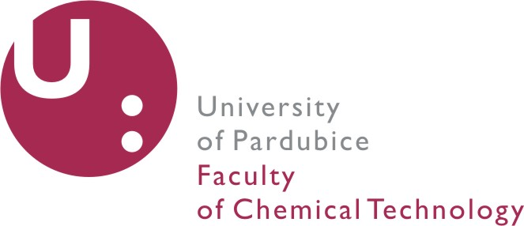

APPLICATION FORM

Doctoral Degree Programme

Academic year: 20 /20

Study Programme
Course | □ full-time | □ part-time

Last (Family) Name
First/Given Name(s)
Date of Birth (DD/MM/YYYY)
Place of Birth
(City and Country)
Nationality
Gender | □ male | □ female
Passport Number /
Valid until
E-mail Address
Telephone Number
Fax Number
Permanent Address
/No. and Street / Post Code and City / Country
Contact Address
(for correspondence)
/No. and Street / Post Code and City / Country

Contact Person in Case of Emergency
First and Last Name
Address
Telephone Number
E-mail Address

University Education – Bachelor Degree
Name of University
Field of Study
Address
Duration of Study
(From -To)

University Education – Master Degree
Name of University
Field of Study
Address
Duration of Study
(From -To)

English Language Skills
Duration of Study
Type of Exam
Score / Grade

List of Applicant’s Written Publications
Please continue on a separate sheet if necessary.

List of subjects taken within the Master Degree Programme
Name of Subject | Date of Exam (MM/YYYY) | Number of Credit Points | Grade
Please continue on a separate sheet if necessary.

Work History (if applicable)
Company’s Name
Company’s Address
Position
Job Description
Duration of Employment (From – To)
Name of Contact Person / Telephone Number

I hereby certify that the information given on this Application form and enclosures is true, complete and accurate. I understand that the condition for enrolment in the PhD study programme is completion of the Master Degree programme (in accordance with the Act no. 111/1998 Coll., the Czech Rep.). I understand that before coming to the Czech Republic I am obliged to arrange the appropriate travel and medical insurance. I truly agree that the University of Pardubice does not take any responsibility for accidents, injuries, property losses, damages etc.

Date and Place: ................................................... Signature: ...................................................
The applicant is obliged to attach to the application an administrative fee payment.

Application fee is CZK 500
University Account Name: Univerzita Pardubice
Account Number: 37030561/0100
Variable symbol 3920
Specific symbol: your date of birth in the format YYMMDD
Bank´s Name: Komercni banka Pardubice
Bank´s Address: Nam. Republiky 222, 530 78 Pardubice, Czech Republic
IBAN: CZ2901000000000037030561
SWIFT: KOMBCZPPXXX
ATTENTION
You must enclose the following documents together with the Application form:
- Curriculum Vitae
- Certified copy of Bachelor Diploma
- Certified copy of Master Diploma
- Three Recommendation Letters (preferably from an academic professional)
- Clear copy of passport
- Two passport format photographs
- Proof of fluency in English

Please note that
- all required documents must be submitted in English
- all translations must be officially certified
- this Application form with all enclosures should be submitted till April 30st, 2017

Please, send this Application form with the relevant additional documents to the following address:
University of Pardubice
Faculty of Chemical Technology
Studentská 573
532 10 Pardubice
Czech Republic

