Do you use application TECKA? Do you know your certificate is here and you can load it into the system ISKaM?

- Load this QR code with your mobile phone

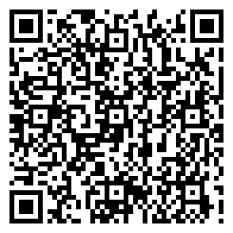
- You can see the link on application TECKA -> open and confirm it.

- The application TECKA needs your confirmation about share your certificate with service ISKaM University:

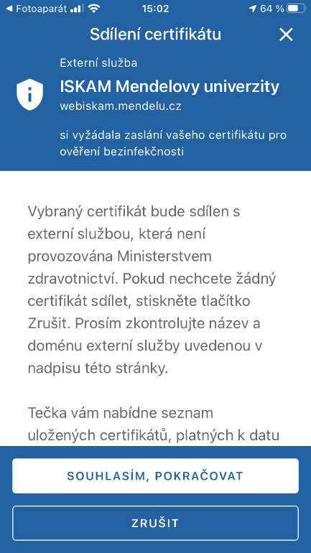

- Choose your certificate, which you want to load into the systém ISKaM and confirm it.

- If everything is OK, you can see this:

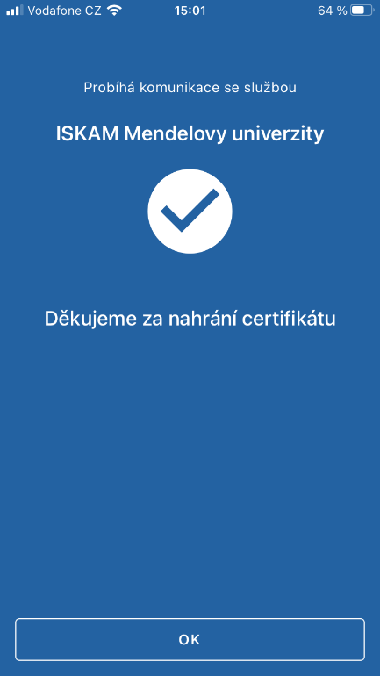

The Faults and problems:

- Some mobile phones cannot open the link on application TECKA. Reason is the application was open before. In this case we recommend you close the application TECKA and load the QR code again.
- If you cannot load your certificate into the systém ISKaM, the application tells you why:
