Information about arrival
Please find here below the map with the different levels of risks. Unfortunately just Czech version is currently at disposal, but it is easy to understand as long as you are able to differ orange, red and dark red colors ☺

nízké riziko = law risk (green)
střední riziko = medium (orange)
vysoké reziko = high (light red)
velmi vysoké = very high (dark red)
extrémní riziko = extrem risk (black)

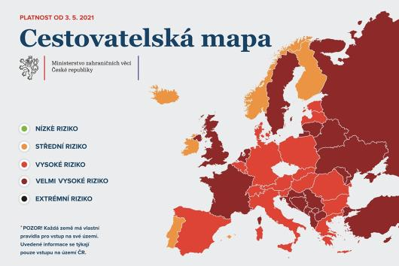

- Testing
See the table Rules for entry in the attachment No. 1
Before departure
Note: All incoming travelers must present a negative Covid test at the border of the Czech Republic (except citizens of a green country).
GREEN COUNTRY: no test
ORANGE COUNTRY: Antigen test not older than 24 hours or PCR test not older than 72 hours before the departure
RED COUNTRY: Antigen test not older than 24 hours or PCR test not older than 72 hours before the departure
DARK RED COUNTRY: PCR test not older than 72 hours before the departure
BLACK COUNTRY: the entry is probihited

After arrival
GREEN COUNTRY: No test
ORANGE COUNTRY: No test
RED COUNTRY: PCR test within 5 days after arrival = 5th day after arrival latest
DARK RED COUNTRY: PCR test no sooner than 5th day after the arrival = 5th day after arrival earliest

If you need to get tested after arrival in the Czech Republic (red and dark red country), we recommend you to do it directly in Pardubice as you have to stay in quarantine while waiting for the result (especially if you are staying in the university dormitory). With all necessary information regarding the quarantine conditions you will be provided by the dormitory office. Please find here below the details of testing points in Pardubice:
Medila Laboratory
- Price 1750 CZK
- Registration is not obligatory
- MeDiLa al. s.r.o. - Google Maps
Pardubice hospital
- Price 1736 CZK
- Registration is obligatory Pardubice - PCR test - indikovaní - Online rezervace - Pardubice - PCR test - indikovaní - Reservio
- the testing is done at building 8 – see the map Orientační mapa areálu | Pardubická nemocnice (nempk.cz)

- How to get to Pardubice
You can find few practical instructions under the following links:
Traveling to Pardubice | University of Pardubice (upce.cz)
Getting to the University of Pardubice | University of Pardubice (upce.cz)

