Important instructions:
Please FILL IN all mandatory fields marked *.
If you have any problems, please let me know immediately.
1/ first step - ECTS arrival – enter your email address (which you will be using for all the communication with our university) for your verification. Go to the weblink sent to your email afterwards and then you are already on Portal and can fill in the registration

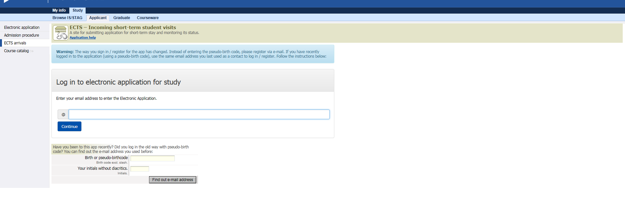

2/ complete the section Personal data and click on „Add incoming study visit“!

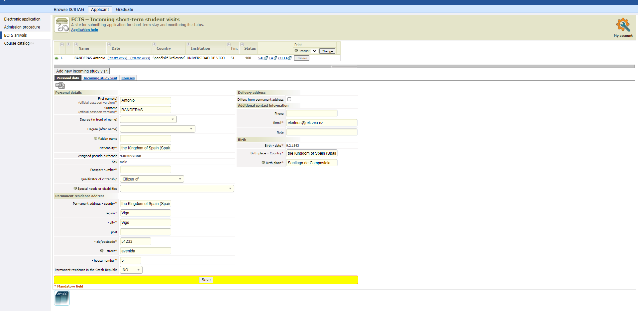
Remember your assigned Birth Code, you will need it several times later and during your stay in Pardubice!!!

3/ click on the section Incoming study visit and complete it:
Expected date of arrival/departure (complete expected dates of your stay - IMPORTANT!!)
Academic year - 2022/23
Funding – Erasmus+: Erasmus
Travel type: semester(s) / virtual component (only if applicable)
Incoming st. visit type - Short study stay
Accommodation – put „yes“ only if you want a place at the university dormitory
Complete the data about your Home institution.

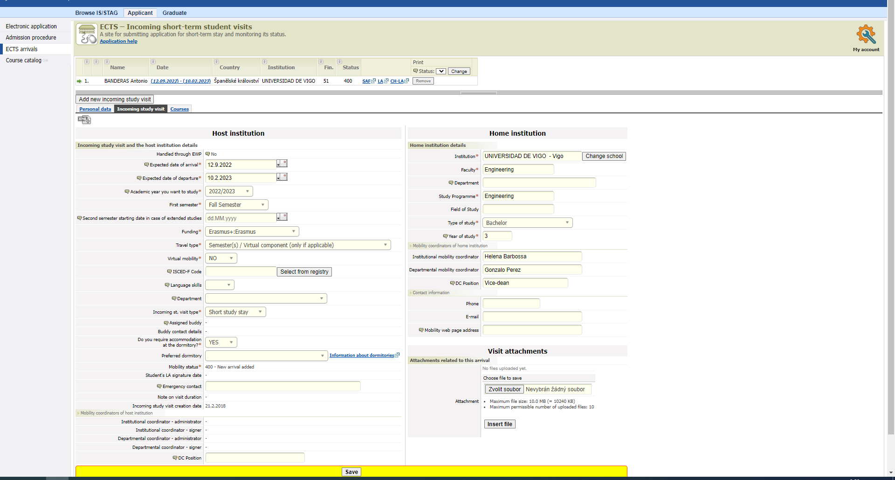
4/ click on the section Courses and complete it:
Click on the faculty you are going to study, there you will see all courses, choose one course and click on ADD COURSES, choose another course and click ADD COURSES...... you do not use any „save“ button in this step, it is saved automatically.
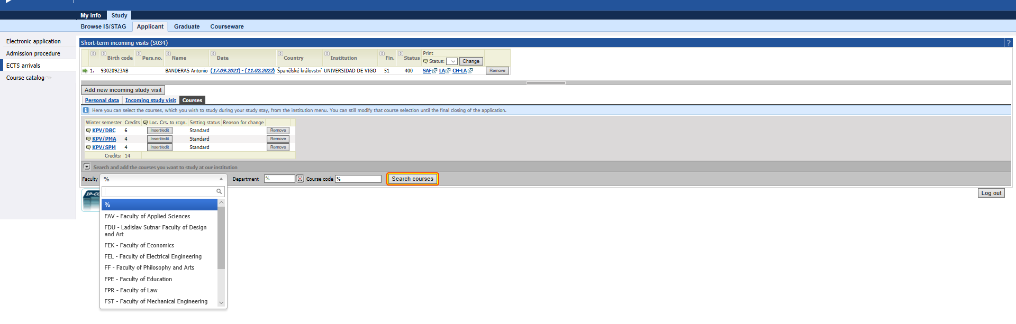

To check the completed offer of your faculty see the List of courses for exchange students
You can also choose 1-2 subjects from a different faculty or our Language center – just discuss it with your faculty coordinator. It is highly recommended to check your choice of courses with the host faculty coordinator. The list of our faculty coordinators is here bellow.
For those of you who are interested in taking Czech language course follow this link and add the abbreviation of the course to your Learning agreement on portal in section “Courses” as well:
Please see the link of the Language Center

In case of any doubts with selected courses, please contact the faculty coordinators.
They will confirm whether the chosen courses are open.
The faculty coordinators will also check your Learning Agreement and sign it.

Faculty | Name of coordinator | e-mail
Faculty of Economics and Administration | Ms Barbora Pašková | barbora.paskova@upce.cz
Faculty of Arts and Philosophy | Ms Michaela Fišerová | michaela.fiserova@upce.cz
Faculty of Transport Engineering | Mr Jiří Pašek | jiri.pasek@upce.cz
Faculty of Chemical Technology | Ms Jana Marková | jana.markova@upce.cz
Faculty of Electrical Engineering and Informatics | Ms Olga Mitchell | olga.mitchell@upce.cz
Faculty of Health Studies | Ms Drahomíra Ciberová | drahomira.ciberova@upce.cz
Faculty of Restoration | Ms Jana Tmejová | jana.tmejova@upce.cz

