PUBLIC EMERGENCY MEDICAL SERVICES FOR ADULTS (GENERAL PRACTITIONER)
NOT LOCATED AT THE HOSPTIAL OF PARDUBICE
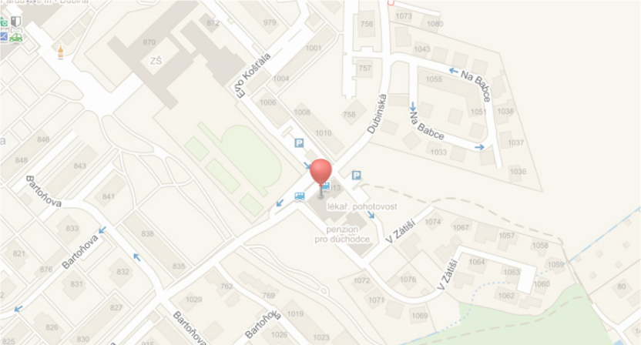
Erno Košťála 1014
Pardubice – Dubina
Tel: +420 466 989 000, +420 775 063 309

Email:
info@novohradsky.eu
novohradsky@seznam.cz

Web:
www.pardubickalekarskapohotovost.cz

Facebook:
www.facebook.com/novohradsky
www.facebook.com/pohotovostpardubice

General practitioner for adults: MUDr. Vítězslav Novohradský, Ph.D.

How to get there by bus? Bus 8 – Bus stop „Dubina penzion“.

Hours of operation for the Emergency Medical Services:
Monday to Friday: 2:00 p.m-10:00 p.m.
Saturday: 10:00 a.m -10:00 p.m
Sunday: 10:00 a.m -10:00 p.m.

MUDr. Vítězslav Novohradský’s hours:
Monday: 2:00 pm - 6:00 pm
Tuesday: 2:00 pm to - 6:00 pm
Wednesday: 8:00 am - 10:00 pm
Thursday: 2:00 pm - 6:00 pm (by appointment only)
Friday: 2:00 pm - 6:00 pm
Saturday: closed
Sunday: closed

PUBLIC EMERGENCY MEDICAL SERVICES FOR KIDS AND TEENAGERS

HOSPITAL OF PARDUBICE
Nemocnice Pardubického kraje, a.s., Kyjevská 44, Pardubice, Building 7 (see the map)
Tel: +420 466 015 405
Office hours:
Monday to Friday: 4:00 pm – 8:00 pm
Saturday, Sunday, bank holidays: 8:00 am - 7:00 pm

A charge of 90 CZK must be paid before the medical check at the automatic collection point in Building 15 (see the map). The receipt is presented to the staff at the appropriate medical ward.

PUBLIC EMERGENCY MEDICAL SERVICES:
TREATMENT OF INJURIES FOR CHILDREN AND TEENAGERS

HOSPITAL OF PARDUBICE
Nemocnice Pardubického kraje, a.s., Kyjevská 44, Pardubice, building 27 (cf. map)
Tel: +420 466 012 888
Opening hours:
Monday to Friday: 3:30 pm – 7:00 pm
Saturday, Sunday, bank holidays: 24h/24h

A charge of 90 CZK must be paid before the medical check at the automatic collection point in Building 15 (see the map). The receipt is presented to the staff at the appropriate medical ward.

DENTAL EMERGENCY

HOSPITAL OF PARDUBICE
Nemocnice Pardubického kraje, a.s., Kyjevská 44, Pardubice building 17 ( cf. map)
Tel: +420 466 015 207
Opening hours:
Monday to Friday: 5:00 pm – 9:00 pm
Saturday, Sunday, bank holidays: 8:00 a.m - 6:00 p.m. (Lunch break: 12:00 am - 1:00 pm)

A charge of 90 CZK must be paid before the medical check at the automatic collection point in Building 15 (see the map). The receipt is presented to the staff at the appropriate medical ward.

PHARMACY (EMERGENCY)

HOSPITAL OF PARDUBICE
Nemocnice Pardubického kraje, a.s., Kyjevská 44, Pardubice, Building 13 (cf. map)
Hours of operation:
Monday to Friday: 4:00 pm – 10:00 pm
Saturday, Sunday, bank holidays: 8:00 am - 1 0:00 pm (Lunch break: 12:00 am - 1:00 pm)

If you have a prescription and go to the pharmacy to collect your medicine during the emergency opening hours, there will be no extra fee.

