HOW TO GET FROM THE PRAGUE AIRPORT TO THE UNIVERSITY OF PARDUBICE (UPa)

The cheapest option from the Prague Airport to the centre is to go by bus.

- 1st OPTION

- Take bus no. 119 (in front of the terminal) to the „Nádraží Veleslavín“ metro station (Green Line A).

- Take the subway from the „Nádraží Veleslavín“ metro station (Green Line A) to the „Muzeum“ metro station.

- Walk to the„Hlavni nádraží“ metro station. (Hlavni nádraží means Main Railway station).
Note: When you buy your bus ticket (directly from the bus driver), you will also be able to use the same ticket on the subway. Ask for the 32 CZK ticket: It is valid for 90 min.

- From the Main Railway station you go to Parducice by a direct train. There are a few different providers: RegioJet, České Dráhy and Leo Express.
The price of a single ticket varies between 90 - 140 CZK for standard class, depending on the provider.

- Once you arrive in Pardubice, you can go to the University of Pardubice by:

- BUS no. 10. Get off the bus at the„Univerzita“ bus stop. (The blue arrow on the map bellow)
The price of the bus ticket is 25 CZK (on the bus) or 16 CZK (at points of sale or ticket vending machines)

- TAXI: we recommend to use these 2 companies: „ Vi3“or „Taxi 88“. They charge approximately 90 CZK. Ask the taxi driver to drop you off near the bus stop „Univerzita“. (The blue arrow on the map bellow)

- 2nd OPTION

- The bus line AIRPORT EXPRESS (AE) connects the Prague Airport with the Prague Main Railway station (Praha Hlavni Nadrazi). You buy the ticket directly from the driver. It costs 60 CZK.
The bus line AE operates:
-daily from 5 am untill 10 pm
-in 30 minute intervals
- the journey takes about 30 minutes

The airport express buses are low-floor vehicles offering easy entry and sufficient space for luggage.
For more information, call the Prague public transit company +420 296 191 817 (daily 7 am – 9 pm)

- From the Main Railway station you go to Pardubice by a direct train. There are a few different providers: RegioJet, České Dráhy and Leo Express.
The price of a single ticket varies between 90 - 140 CZK for standard class, depending on the provider .

- Once you arrive in Pardubice, you can go to the University of Pardubice by:
- BUS no. 10. Get off the bus at the„Univerzita“bus stop. (The blue arrow on the map bellow)
The price of the bus ticket is 25 CZK (on the bus) or 16 CZK (at points of sale or ticket vending machines)
- TAXI: we recommend to use „ Vi3“or „Taxi 88“. They charge approximately 90 CZK. Ask the taxi driver to drop you off near the bus stop „Univerzita“. (The blue arrow on the map bellow)

- For more info: http://czech-transport.com/index.php?id=154

Note:
If you have arranged accommodation at the University dormitories, go to block KC. The receptionist will assist you.

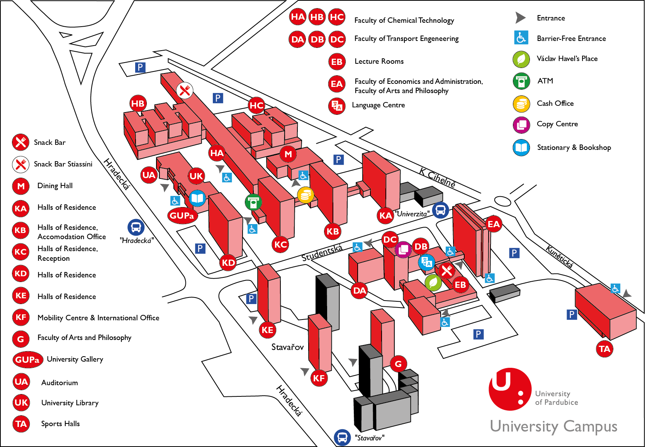

For more details about the journey from Prague airport to the University of Pardubice go to the website of the International Erasmus Student Network of Pardubice: http://esn.upce.cz/content/travel-instructions

