Annex 4B: Layout of Thesis

See the separate annex

MANDATORY PAGE (only for the printed version of the thesis)
Text on the boards (only for the printed version of the thesis)
Times New Roman font, size 22. The recommended length of the Bachelor's thesis is 35 pages of the actual text (approx. 70,000 characters), Master's thesis 50 pages (approx. 100,000 characters). This page is always in the language of the thesis (see Annex 4A: Terminology).

THE UNIVERSITY OF PARDUBICE FACULTY OF ARTS AND PHILOSOPHY

BACHELOR'S THESIS

2019 Josef Novák

MANDATORY PAGE
Titulní list (a numbered page, the number is not displayed)
This is the beginning of the numbering of the thesis. The page and the following pages are included in the paging, but their numbers are not displayed. The first page on which the number is displayed is usually the introduction. Times New Roman font size 14. This page is always in the language of the thesis (see Annex 4A: Terminology).

The University of Pardubice Faculty of Arts and Philosophy

Information Literacy Bachelor's Thesis

2019 Josef Novák

MANDATORY PAGE
Thesis assignment 1 (a numbered page, the number is not displayed)
In the printed copy and the electronic version of the thesis, an assignment form is inserted, which the student will receive in PDF from the faculty. Instead of signatures, it bears names with the abbreviation b.o.h. (by own hand).

MANDATORY PAGE
Thesis assignment 2 (a numbered page, the number is not displayed)
The second page of the assignment (i.e. two pages).

2,5 cm
3,5 cm 1,5 cm

Author's Declaration (a numbered page, the number is not displayed)
MANDATORY PAGE

Sign one copy of the declaration by hand (delete the abbreviation b.o.h.) and submit it to the faculty along with a printed copy of the thesis. In this printed copy and in the electronic version of the thesis, however, the declaration will bear no signature, only the abbreviation b.o.h. after your name.
The whole thesis uses 1.5 line spacing, Times New Roman font, size 12 (approx. 30 - 31 lines per page). The text is aligned to the block.
I declare:
The thesis entitled ……………………………………………………………… is my own work. All literary sources and information that I used in the thesis are referenced in the bibliography.
I have been acquainted with the fact that my work is subject to the rights and obligations arising from Act No. 121/2000 Sb., On Copyright, on Rights Related to Copyright and on Amendments to Certain Acts (Copyright Act), as amended, especially with the fact that the University of Pardubice has the right to conclude a license agreement for the use of this thesis as a school work under Section 60, Subsection 1 of the Copyright Act, and that if this thesis is used by me or a license to use it is granted to another entity, the University of Pardubice is entitled to request a reasonable fee from me to cover the costs incurred for the creation of the work, depending on the circumstances up to their actual amount.
I acknowledge that in accordance with Section 47b of Act No. 111/1998 Sb., On Higher Education Institutions and on Amendments to Other Acts (Higher Education Act), as amended, and the Directive of the University of Pardubice No. 7/2019 Rules for Submission, Publication and Layout of Theses, as amended, the thesis will be published through the Digital Library of the University of Pardubice.

In Pardubice on

Josef Novák b.o.h.

2,5 cm

MANDATORY PAGE
Acknowledgements (a numbered page, the number is not displayed)
Optional page, a section is where you thank those who have helped and supported you during the research, the supervisor, consultants, family …

MANDATORY PAGE
Abstract and keywords (a numbered page, the number is not displayed)
This information about the thesis corresponds to the data entered into the IS STAG. The data must always be given in the language of the thesis, Czech and English.

ANOTACE
Brief summary of the thesis in 3-4 sentences, written in the language of the thesis.

Example: Práce je věnována stručným dějinám tělovýchovy a sportu se zaměřením na jejich ženská odvětví a stručnému vývoji dámského odívání se zaměřením na sportovní oblečení. Postihuje období od druhé poloviny
19. století do druhé světové války a zahrnuje území střední Evropy se zaměřením na České země. Zabývá se vlivem sportu na ženské odívání z hlediska jeho vývoje v uvedeném časovém období.

KLÍČOVÁ SLOVA
4-6 words that accurately describe the content of the work, written with a lowercase initial letter, usually given in the plural. General (redundant) terms, characters and abbreviations are not to be used ("eg", "etc.", "…", "etc.",…).
Example: sport, móda, ženy, odívání, 19.-20. století

TITLE
The title in English.

Example: Effect of Sport on Women´s Clothing: since the Second Half of the 19th Century till the Second World War

ABSTRACT
The abstract in English.

Example: The work deals with a brief history of the physical training and sport with a view to their woman branches and with a progress of the woman clothing with a view to the sport clothes. It focuses on the second half of the 19th century till the 2nd World War in the Middle Europe, especially in the Czech countries. Focuses in the influence of the sport at the woman clothing with a point of view its progress.

KEYWORDS
Keywords in English.

Example: sport, fashion, women, clothing, 19th-20th century

MANDATORY PAGE
Contents (a numbered page, the number is not displayed)
Automatically generated contents.

CONTENTS

LIST OF ILLUSTRATIONS AND TABLES .………………………………...8 LIST OF ABBREVIATIONS AND SYMBOLS ………………………………9
TERMINOLOGY ……………………………………………………………10 INTRODUCTION …………….……………………………………………...11 CITATION METHODS ….………….…………………….……………… 12
1.1 The Harvard system ………………………………..…………..…….12
    - Example of in-text citation …..………………………………………12
    - Example of a list of bibliographic citations …………………..……..12 1.2 Numeric referencing ..…………………………………….………….13
    - Example of in-text citation .………………………….………………13
    - Example of a list of bibliographic citations .………………………..13 1.3 Running notes …….………………………………………………….13 1.3.1 Example of in-text citation .…………………………… 13
CONCLUSION ………………………………………………………….……16 BIBLIOGRAPHY ……….……………………………………………………19 ANNEXES ……..…………………………………………………………….20

List of illustrations and tables (a numbered page, the number is not displayed)
A complete list of illustrations and tables in the order given below. With a larger number of different kinds (photographs, diagrams, graphs,…), it is possible to list them separately. Lists of figures, tables, diagrams, etc. should also be generated automatically.

LIST OF ILLUSTRATIONS AND TABLES
Figure 1 - Functional literacy model enriched with ICT literacy ………… 14
Table 2 - General principles of interactive teaching ………………………….15

List of abbreviations and symbols (a numbered page, the number is not displayed)
Abbreviations and symbols must be explained when they first appear in the text. If the thesis contains a large number of abbreviations and symbols, it is advisable to include them in this list.

LIST OF ABBREVIATIONS AND SYMBOLS

AACR – Anglo-American Cataloguing Rules ISBN – International Standard Book Number
…

Terminology (a numbered page, the number is not displayed)
On this page you can list the terms used in the thesis and their interpretation.

TERMINOLOGY

Information Literacy: the ability of an individual to search for, process, evaluate and use information through available information methods and technologies.
…

MANDATORY PAGES
Thesis text – Introduction (a numbered page, the number is displayed)
The text is divided into numbered chapters (chapter name: font size 16, always starting on a new page), sections (section name: font size 14) and subsections (section name: font size 13). The introduction does not have a number or can be denoted by the number zero.

The individual paragraphs are aligned to the block.

For more see ČSN ISO 2145 Documentation – Numbering of sections and subsections of written documents and ČSN ISO 01 6910 Layout of type-written documents or documents processed by text editors.

INTRODUCTION

…

Thesis text (a numbered page, the number is displayed)
ČSN ISO 690 is used (unless otherwise stated) to refer to the sources used. For more see http://www.citace.com/soubory/csniso690-interpretace.pdf
Doslovná citace (citát) musí být vyznačena (uvozovky, kurzíva). V odkazu na literaturu v textu musí být uvedena strana.
- CITATION METHODS

A bibliographic citation is a summary of data on a cited publication or its part, enabling its identification. It is necessary to cite all sources used by the author, according to precisely defined rules, so that the original source can be found by anyone. When creating bibliographic citations, we follow ČSN ISO 690 (01 0197) effective from April 1, 2011. According to this standard, the author chooses one method of referencing, which must be followed throughout the thesis. The bibliography is also governed by the chosen method of referencing (see below).

  - The Harvard system

Directly in the text, the author, the year of publication and a reference to the relevant part of the document (e.g. page number) shall be given in round brackets. In the case of multiple sources from the same author and the same year of publication, the lowercase letter of the alphabet shall be given after the year of publication (a, b, c,..).

The list of bibliographic citations is then arranged in alphabetical order according to the authors' surnames and the citation states the date of publication immediately after the author..

    - Example of in-text citation

At the same time, however, it must be ensured that the long-term availability and usability of the digital object is maintained (Strathmann, 2008a, pp. 39–40).

Baker (2007) describes various examples of student activism activities on college campuses as well as students' involment and stake in many areas of scholarly communication in the academy.

    - Example of a list of bibliographic citations

STRATHMANN, S., 2008a. Trusted repositories, In DPE/Planets/CASPAR/nestor Joint Training Event: Starting Out : Presererving Digital Objects – principles and practise : October 13th–17th 2008, Prague, Czech Republic [online]. [cit. 2010-05-30]. Available at: http://www.digitalpreservationeurope.eu/PragTrustedRepositories.pdf

BAKER, G., 2007. Student activism: how students use the scholarly communication system. Research Libraries News, 68(10), s. 636-638.

  - Numeric referencing
The relevant citation source is referenced by a number in round, square brackets or superscript. Numbers are assigned to documents according to the order in which they are cited in the thesis. If the same source is cited several times, the number from the first occurrence shall always be given. When referring to a part of a document, the page number shall also be given after the number.

    - Example of in-text citation
At the same time, however, it must be ensured that the long-term availability and usability of the digital object is maintained1 pp. 39–40.
At the same time, however, it must be ensured that the long-term availability and usability of the digital object is maintained (1 pp. 39–40).
Baker2 describes various examples of student activism activities on college campuses as well as students' involment and stake in many areas of scholarly communication in the academy.

    - Example of bibliographic citations
- STRATHMANN, S. Trusted repositories. In: DPE/Planets/CASPAR/nestor Joint Training Event: Starting Out : Presererving Digital Objects – principles and practise : October 13th–17th 2008, Prague, Czech Republic [online]. 2008 [cit. 2010-05-30]. Available at: http://www.digitalpreservationeurope.eu/PragTrustedRepositories.pdf
- BAKER, G. Student activism: how students use the scholarly communication system. Research Libraries News, 2007, 68(10), s. 636–638.

  - Running notes
The reference to a cited document is indicated by a number which refers to a footnote. Notes are numbered in the order in which they appear in the text. A note that refers to a document already cited should state the entire citation of the document or indicate the number of an earlier note with page numbers. In the bibliography, the sources are arranged alphabetically.

    - Example of in-text citation
At the same time, however, it must be ensured that the long-term availability and usability of the digital object is maintained1.
As stated earlier by Strathmann, it must also be ensured that the long- term availability and usability of the digital object is maintained2.
Baker3 describes various examples of student activism activities on college campuses as well as students' involment and stake in many areas of scholarly communication in the academy.

1 STRATHMANN, S. Trusted repositories, In DPE/Planets/CASPAR/nestor Joint Training Event: Starting Out : Presererving Digital Objects – principles and practise : October 13th-17th 2008, Prague, Czech Republic [online]. 2008 [cit. 2010-05-30]. Available at: http://www.digitalpreservationeurope.eu/ PragTrustedRepositories.pdf
2 STRATHMANN, S., ref. 1, p. 39.
3 BAKER, G. Student activism: how students use the scholarly communication system. Research Libraries News, 2007, 68(10), p. 636-638.

Figures are numbered uniformly from the beginning to the end of the thesis. The caption is always placed below the figure. The figure is also given in the introductory part of the thesis in the List of illustrations and tables. In this particular example, the running notes method is used for referencing.

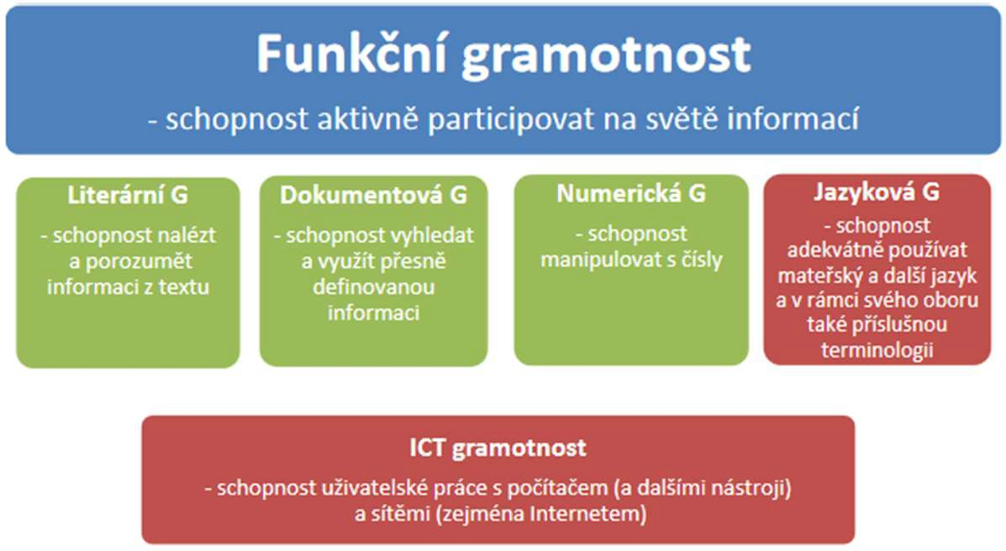

Figure 1 - Functional literacy model enriched with ICT literacy4

Functional literacy
- the ability to actively participate in the world of information

Literary L – the ability to find and understand information from a text Document L – the ability to search for and use precisely defined information
Numerical L – the ability to use and understand mathematics
Language L – the ability to use one's mother tongue and other languages adequately and also the relevant terminology within one's field
ICT literacy – the ability of user work with computer (and other tools) and networks (especially the Internet)

4 AKVŠ ČR. Komise IVIG. Použití definic informa1čn4í gramotnosti v práci komise IVIG. Op. cit..

Tables are numbered uniformly from the beginning to the end of the work. The caption is always placed above the table. The table is also given in the introductory part of the thesis in the List of illustrations and tables. In this particular example, the running notes method is used for referencing.

Table 1 - General principles of interactive teaching5

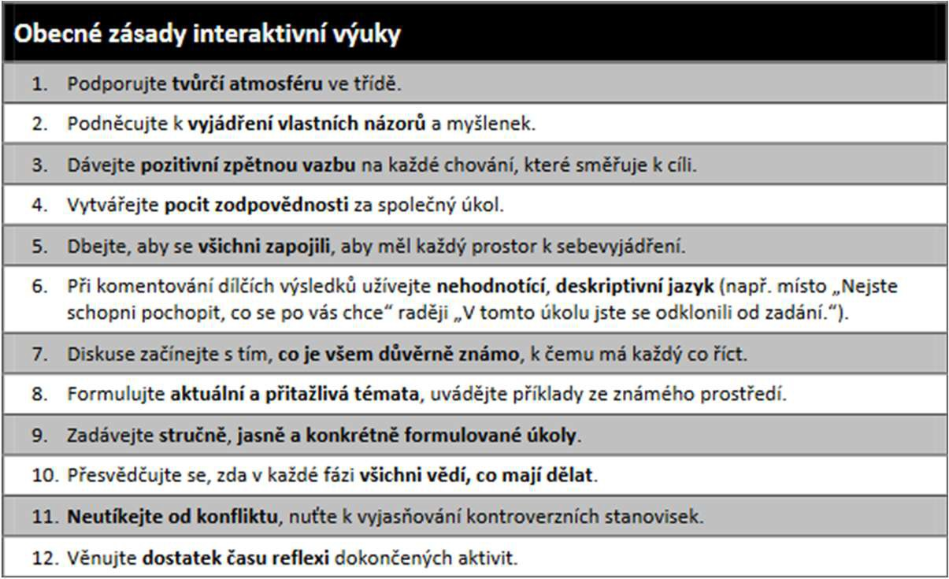
General principles of interactive teaching
      - Encourage a creative atmosphere in the classroom.
      - Encourage the students to express their own opinions and ideas.
      - Give positive feedback on any behavior that leads to a goal.
      - Create a sense of responsibility for a common task.
      - Make sure everyone is involved so that everyone has room to express themselves.
      - Use non-evaluative, descriptive language when commenting on partial results (e.g. instead of "You are not able to understand what you are asked to do" rather "In this task you deviated from the assignment.").
      - Start the discussion with what is familiar to everyone, what everyone has something to say to.
      - Formulate current and attractive topics, give examples from familiar contexts.
      - Assign briefly, clearly and specifically formulated tasks.
      - Make sure everyone knows what to do at each stage.
      - Do not run away from conflict, make the students clarify controversial positions.
      - Spend enough time reflecting on completed activities.

15

MANDATORY PAGE
Thesis text - Conclusion (a numbered page, the number is displayed)

- CONCLUSION

…

16

List of bibliographic citations (a numbered page, the number is displayed)
MANDATORY PAGE

The form of the list of bibliographic citations is governed by the selected type of referencing in the text of the thesis (Harvard system, numerical references or running notes). A clear and detailed methodology for citation and creation of bibliographic citations according to the ČSN ISO 690 standard (01 0197) can be found at http://www.citace.com/soubory/csniso690- interpretace.pdf. This methodology also contains a wide range of practical examples of citations of individual types of documents. The following text was processed on the basis of this methodology, but it is only a simplified and shortened version thereof.

Examples of bibliographic citations of the most common types of publications:

- Printed resources:

- Monographs

no author
Anglicko-český, česko-anglický praktický slovník. 2., rozš. vyd. Hradec Králové: TZ-one, 2007, 1199 p. ISBN 978-80-903606-4-8.

- author
KOPECKÝ, Kamil. E-learning (nejen) pro pedagogy. 1. vyd. Olomouc: HANEX, 2006, 125 p. ISBN 80-857-8350-9.

- authors
BREIVIK, Patricia Senn and E. Gordon GEE. Information Literacy: Revolution in the Library. New York: American Council on Education and Macmillan Inc., 1989. ISBN 9780029114407.

- authors
PRŮCHA, Jan, Eliška WALTEROVÁ a Jiří MAREŠ. Pedagogický slovník. 6., rozš. a aktualiz. vyd. Praha: Portál, 2009, 395 p. ISBN 978-807-3676-476.

corporation = author as an organization
NÁRODNÍ PEDAGOGICKÁ KNIHOVNA KOMENSKÉHO. 90 let Národní pedagogické knihovny Komenského: 1919-2009. Vyd. 1. Praha: Ústav pro informace ve vzdělávání, 2009, 43 p. ISBN 978-80-211-0583-6.

- Thesis
NOVÁK, Josef. Information Literacy. Pardubice, 2012. 100 s. Diplomová práce. Univerzita Pardubice, Faculty of Arts and Philosophy. Vedoucí práce Ing. Jana Novotná, Ph.D.

- Act

ČESKO. Zákon č. 111 ze dne 22. dubna 1998 o vysokých školách a o změně
a doplnění dalších zákonů (zákon o vysokých školách). In: Sbírka zákonů České republiky. 1998, částka 39, s. 5388-5419. Also available at:
http://aplikace.mvcr.cz/archiv2008/sbirka/1998/sb039-98.pdf. ISSN 1211-1244.

- A paper in proceedings

KVĚTOŇ, Karel. Zpětné vazby v učení. In: SEDLÁČEK, Jan, editor. Sborník příspěvků ze semináře a soutěže e-learning 2002. Vyd. 1. Hradec Králové: Gaudeamus, 2003, s. 204-208.
ISBN 80-7041-509-6.

- An article in a journal

BEHRENS, S. J. A conceptual analysis and historial overview of information literacy. College
& Research Libraries. 1994, 35(4), 309–322. ISSN 0010-0870.

- Standard

ČSN ISO 690. Informace a dokumentace – Pravidla pro bibliografické odkazy a citace informačních zdrojů. Praha: Úřad pro technickou normalizaci, metrologii a státní zkušebnictví, 2011. 40 s. Třídící znak 01 0197.

- Patent

NOVÁK, Jiří a Jan NOVÁK. Malá peletizační linka. IPC: B 27 N 3/08, B 27 N 3/18. Česká republika. Užitný vzor, CZ 18719 U1. 2008-07-07. Dostupné také z: http://spisy.upv.cz/UtilityModels/FullDocuments/FDUM0018/uv018719.pdf

- Electronic resources:

- Electronic monograph (e-book, website = web)

KAPLAN, Robert B. a Paul BRUTHIAUX. Directions in applied linguistics: essays in honor of Robert B. Kaplan [online]. Buffalo: Multilingual Matters Ltd., c2005, 327 p. [cit. 2012-04-18]. Multilingual matters (Series), 133. ISBN 18-535-9850-X.

UNIVERZITA PARDUBICE. Univerzita Pardubice [online]. 2011 [cit. 2011- 05-30]. Available at: http://www.upce.cz/index.html.

Moodle [online]. 2001 [cit. 2011-06-07]. Available at: http://moodle.cz.

- WWW page (i.e. part of the website = web)

SONIC FOUNDRY INC. Mediasite Player. Online Multimedia Presentations [online]. ©2011 [cit. 2011-06-05]. Available at: http://www.sonicfoundry.com/mediasite/player/.

AKVŠ. Komise IVIG. Jak rozumíme informační gramotnosti. Odborná komise pro informační vzdělávání a informační gramotnost na vysokých školách [online]. 2010, 16. 11. 2010 [cit. 2011-06-15]. Available at: http://www.ivig.cz/informacni-gramotnost.html.

DROBÍKOVÁ, Barbora. Elektronické knihy a katalogy knihoven. In INFORUM 2011: 17. ročník konference o profesionálních informačních zdrojích, Praha 24. - 26. května 2011 [online].
Praha: Albertina icome Praha, 2011 [cit. 2011-06-30]. Available at WWW: http://www.inforum.cz/pdf/2011/drobikova-barbora.pdf. ISSN 1801–2213.
LANDOVÁ, Hana. Informační gramotnost v kontextu vzdělávání s důrazem na vysoké školy. Ikaros [online]. 2003, 7(4) [cit. 2011-05-20]. Available at: http://www.ikaros.cz/node/1322. ISSN 1212-5075.

HOIC-BOZIC, N., V. MORNAR and I.BOTICKI. A blended learning approach to course design and implementation. IEEE Transaction on Education [online]. 2009, 52(1), 19 [cit. 2009-11- 29]. Available at: http://ieeexplore.ieee.org/stamp/stamp.jsp?tp=&arnumber=4544803&is number=4774054. ISSN 0018-9359.
- A paper in online proceedings
- An article in an electronic journal

- BIBLIOGRAPHY

ČSN ISO 690. Informace a dokumentace – Pravidla pro bibliografické odkazy a citace informačních zdrojů. Praha: Úřad pro technickou normalizaci, metrologii a státní zkušebnictví, 2011. 40 s. Třídící znak 01 0197.

- AKVŠ ČR. Komise IVIG. Použití definic informační gramotnosti v práci komise IVIG. Odborná komise pro informační vzdělávání a informační gramotnost na vysokých školách [online]. 2010, 16. 11. 2010 [cit. 2011-05- 15]. Available at: http://www.ivig.cz/pouziti-informacni-gramotnosti.html.
- AKVŠ ČR. Komise IVIG. Standardy informační gramotnosti vysokoškolského studenta.
3. Odborná komise pro informační vzdělávání a informační gramotnost na vysokých školách [online]. 2010, 16. 11. 2010 [cit. 2011-05-15]. Available at: http://www.ivig.cz/standardy-student.html.
- AKVŠ. Komise IVIG. Jak rozumíme informační gramotnosti. Odborná komise pro informační vzdělávání a informační gramotnost na vysokých školách [online]. 2010, 16. 11. 2010 [cit. 2011-06-15]. Available at: http://www.ivig.cz/informacni-gramotnost.html.
- BEHRENS, S. J. A conceptual analysis and historial overview of information literacy. College & Research Libraries. 1994, 35(4), 309–322. ISSN 0010-0870.
- BREIVIK, Patricia Senn. Making the Most of Libraries: In the Search for Academic Excellence. Change. 1987, 19(4), 44-52. ISSN 0009-1383.
- CILIP. Information literacy: definition. CILIP: Policy and advocacy.[online]. 2010,16. 11. 2010 [cit. 2011-05-15]. Available at: http://www.cilip.org.uk/get-involved/advocacy/learning/information- literacy/Pages/definition.aspx.
- ČLOVĚK V TÍSNI. Interaktivní metody výuky. Varianty [online]. ©2008 [cit. 2011-06- 05]. Available at: http://www.varianty.cz/download/pdf/texts.pdf.

19

Annexes (a numbered page, the number is displayed)
Extensive annexes (additional illustrations, graphs, tables, maps, plans,…) may be included in this section. Each annex begins on a new page and is marked with a capital letter (Annex A, Annex B,…). The page numbering follows the previous section.

- ANNEXES

Annex A Components of functional and information literacy ……….………21 Annex B Information literacy model ………………………………………….22

20

Annex A Components of functional and information literacy6

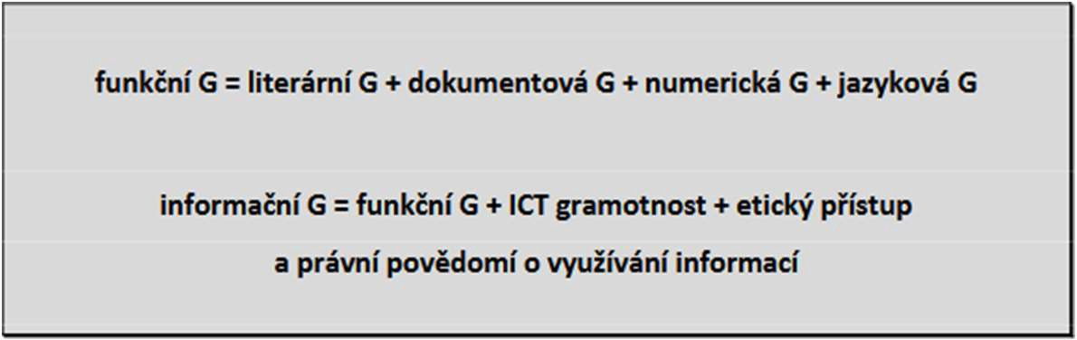
functional L = literary L + documentation L + numeric L + language L information L = functional L + ICT literacy + ethical approach
and legal awareness of the use of information

Annex B Information literacy model7

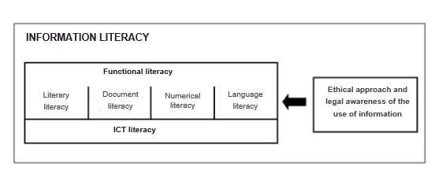

7 AKVŠ ČR. Komise IVIG. Použití definic informační gramotnosti v práci komise IVIG. Op. cit.

